**Linux commands**

1. **pwd :** it prints the full [pathname](https://www.computerhope.com/jargon/p/path.htm) of the current working [directory](https://www.computerhope.com/jargon/d/director.htm).

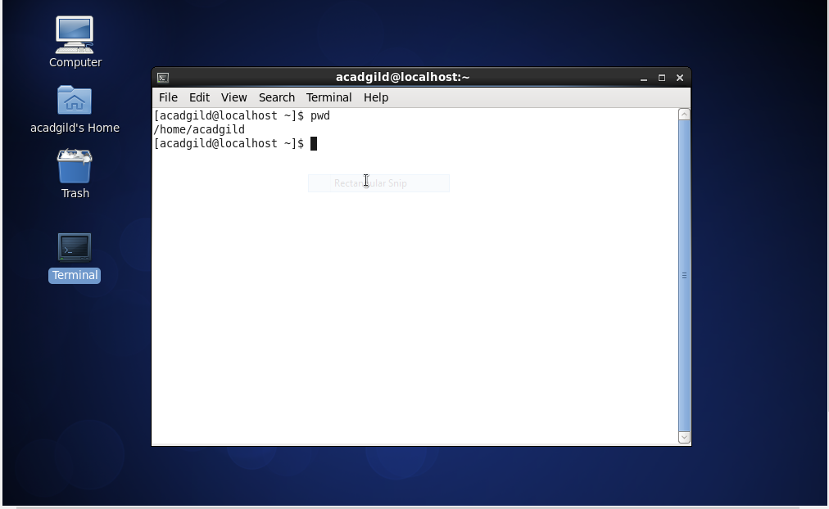

1. **vi :** Creates a new file if it already does not exist, otherwise opens an existing file.

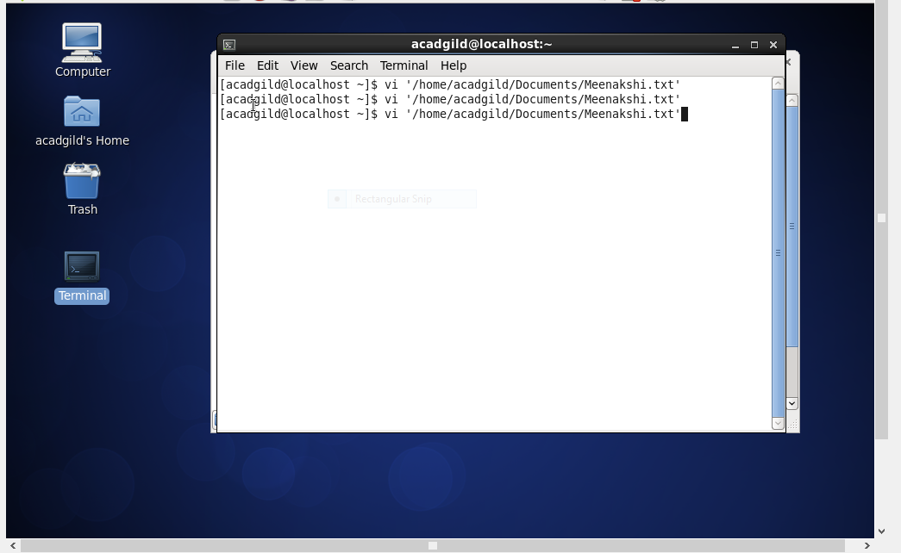

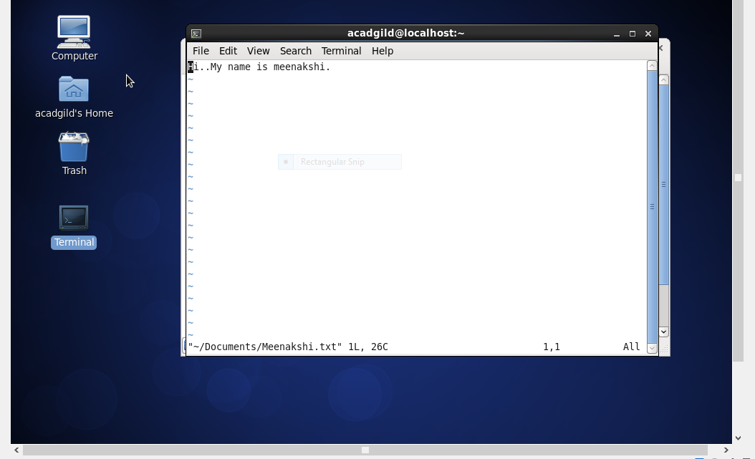

1. **touch :** This command is the easiest way to create new, empty files. It is also used to change the timestamps.

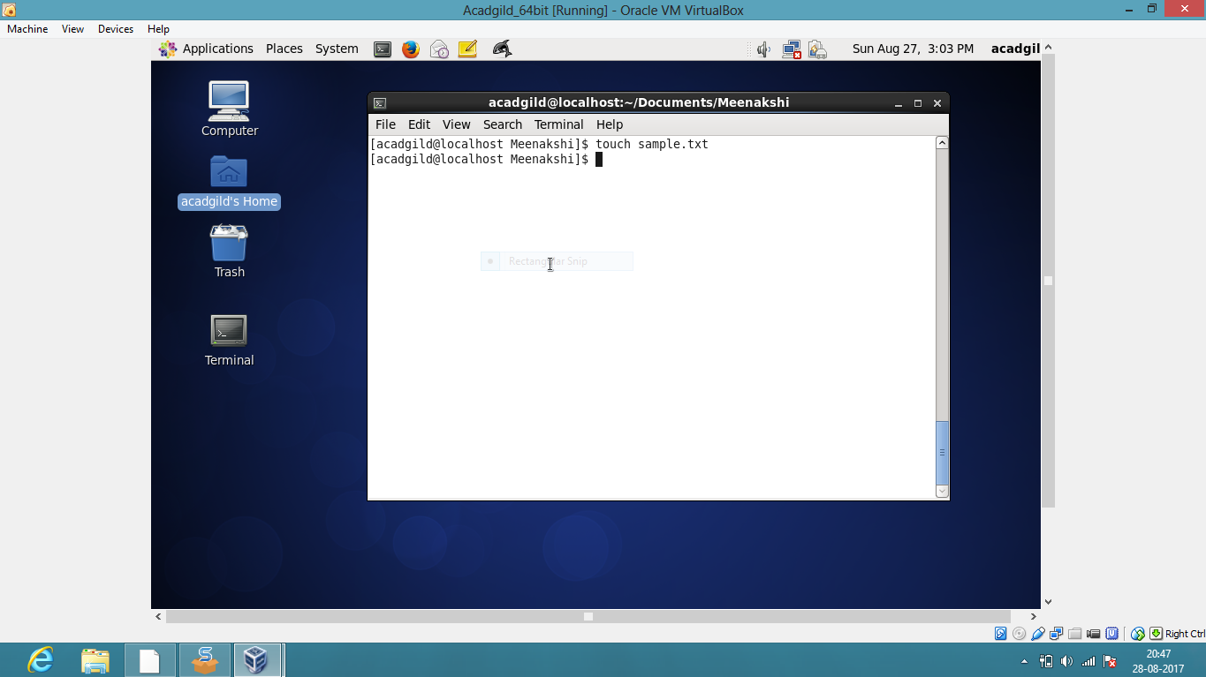

1. **mkdir :** If the specified *DIRECTORY* does not already exist, **mkdir** creates it.

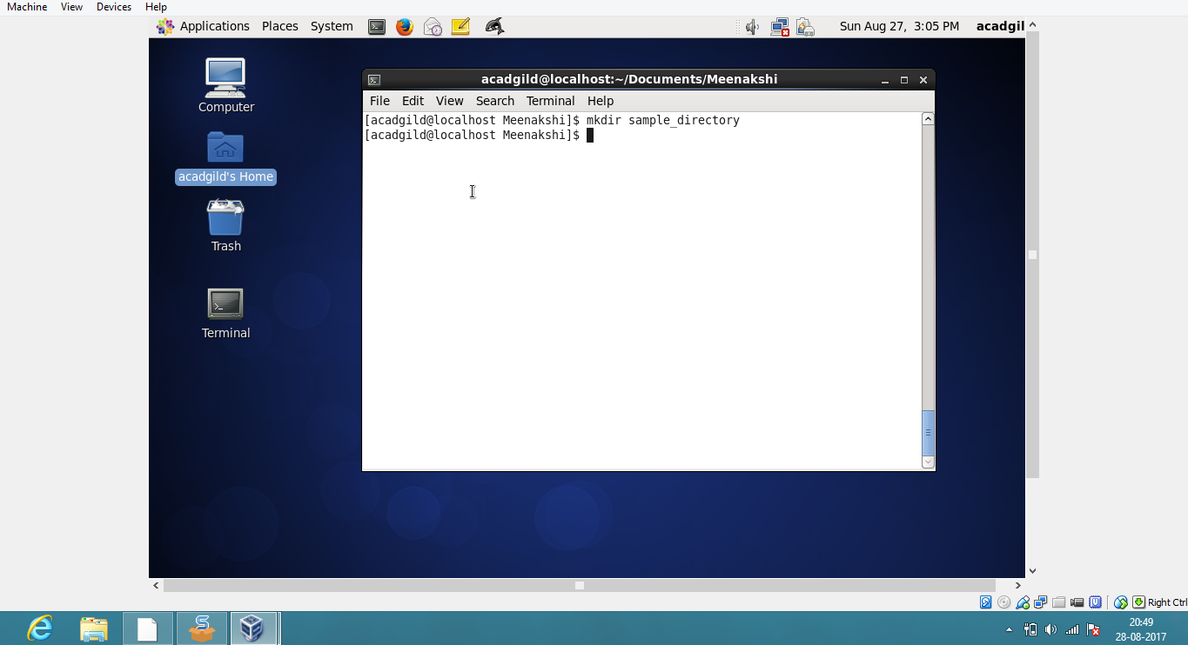

1. **rm :** It removes each specified file. By default, it does not remove directories. If the *-I* or *--interactive=once* option is given, and there are more than three files or the *-r*, *-R*, or *--recursive* are given, then it prompts the user for whether to proceed with the entire operation. If the response is not affirmative, the entire command is aborted.

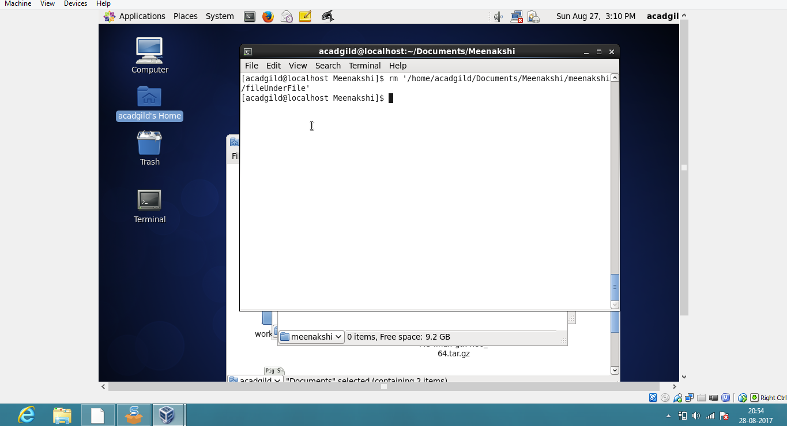

1. **ls :** *ls* is a Linux shell command that lists directory contents of files and directories.

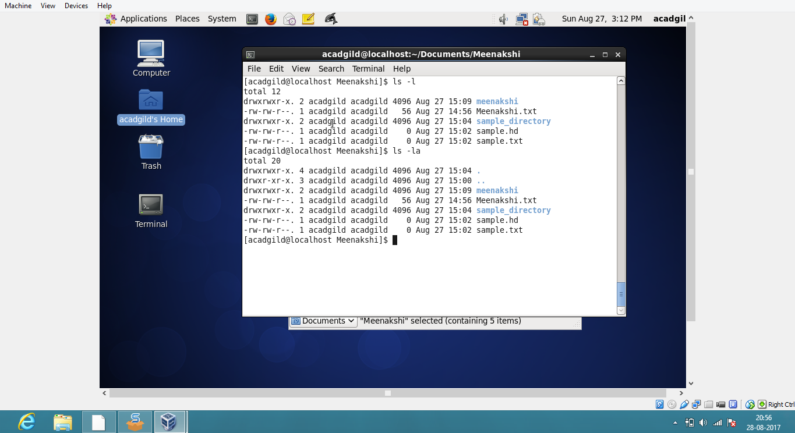

1. **echo :** It is one of the most commonly and widely used in scripting language and batch files to display a line of text/string on standard output or a file or declare a variable and echo its value**.**

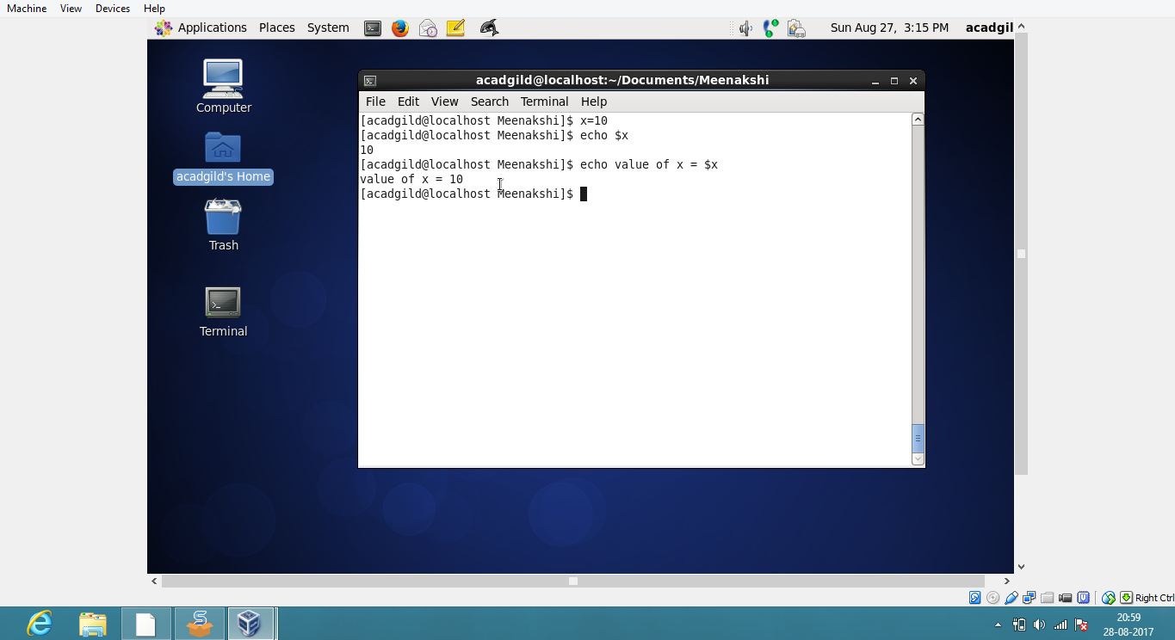

1. **cat:** This command allows us to create single or multiple files, view contain of file, concatenate files and redirect output in terminal or files.

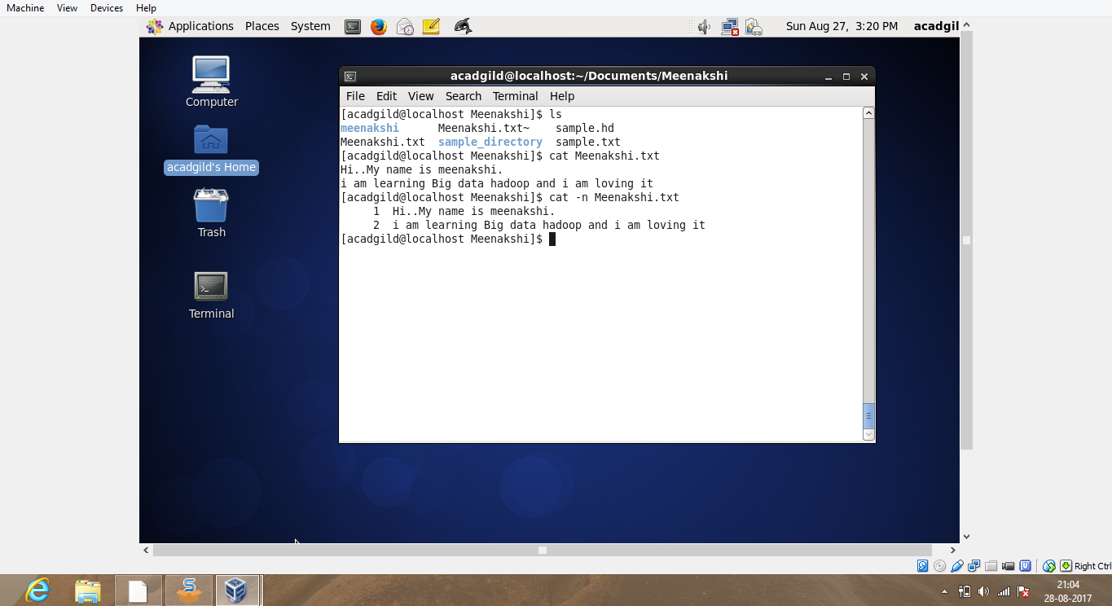

1. **who :** It isuseful to display users who are currently logged in your server.

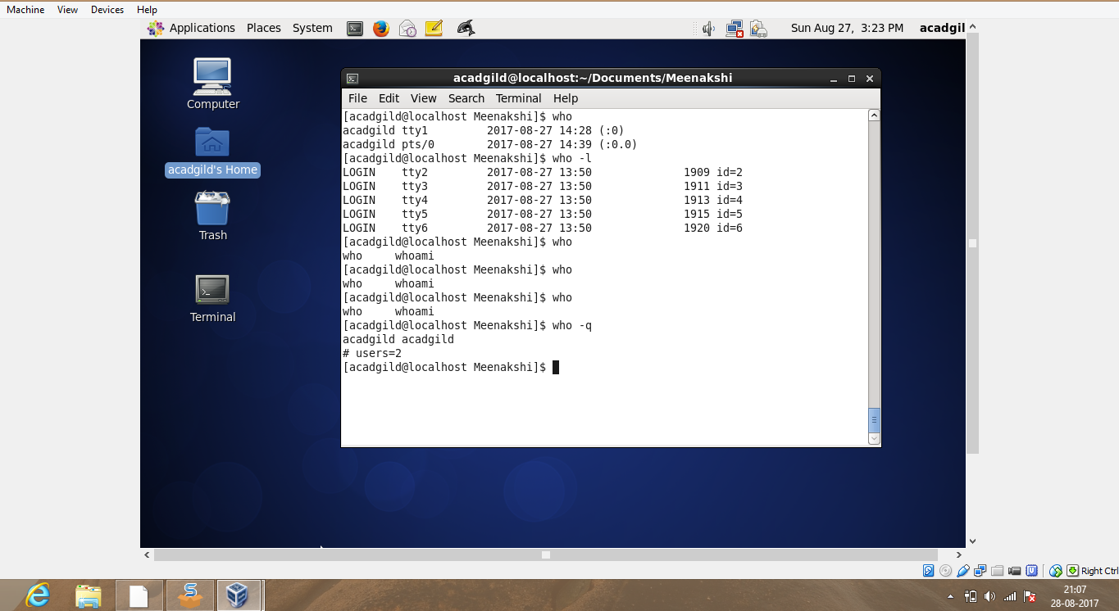

1. **cd :** used to change the current working directory in operating systems.

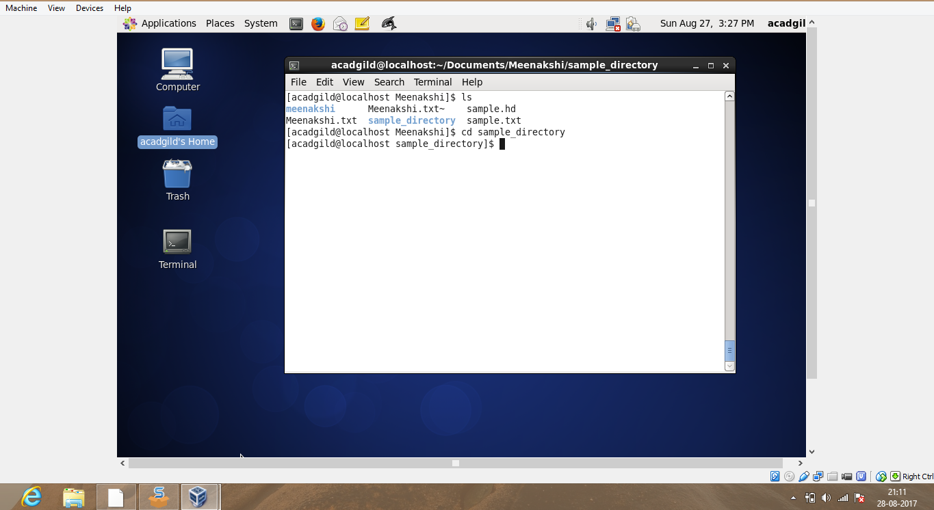

1. **date :** This command is helpful to display date in several formats. It also allows you to set systems date and time.

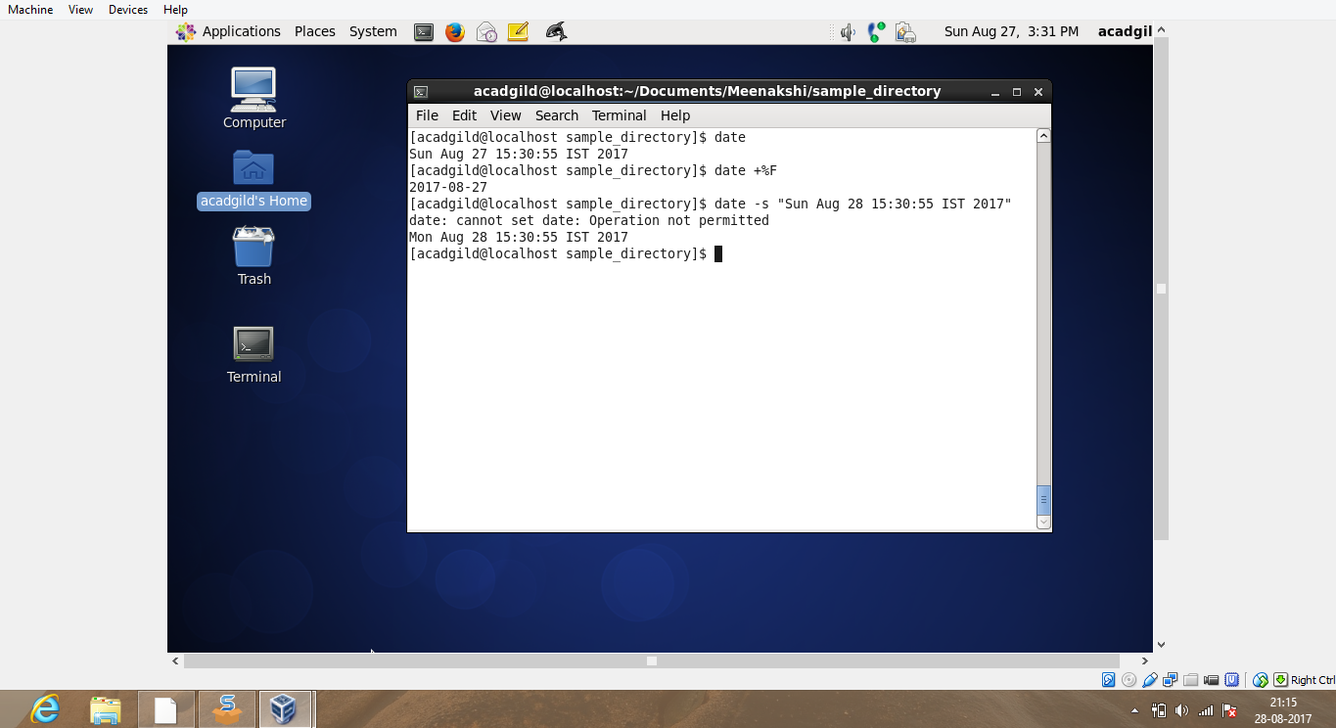

1. **cal :** Thiscommand is a command line utility for displaying a calendar in the terminal. It can be used to print a single month, many months or an entire year.

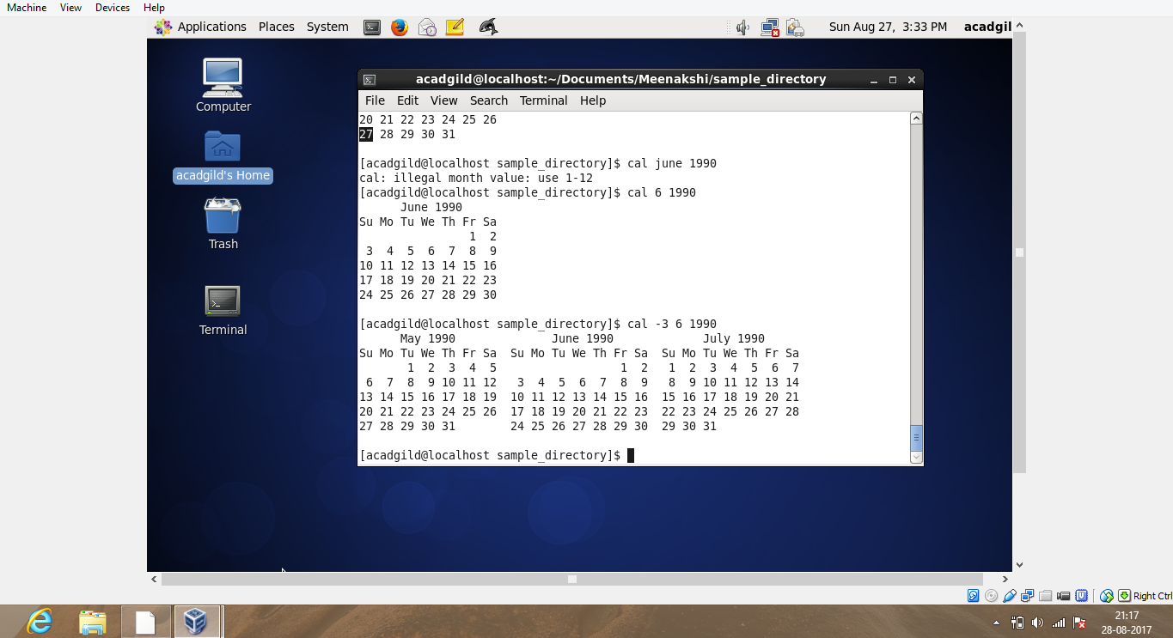

1. **mv :** It renames file SOURCE to DEST, or moves the SOURCE file (or files) to DIRECTORY.

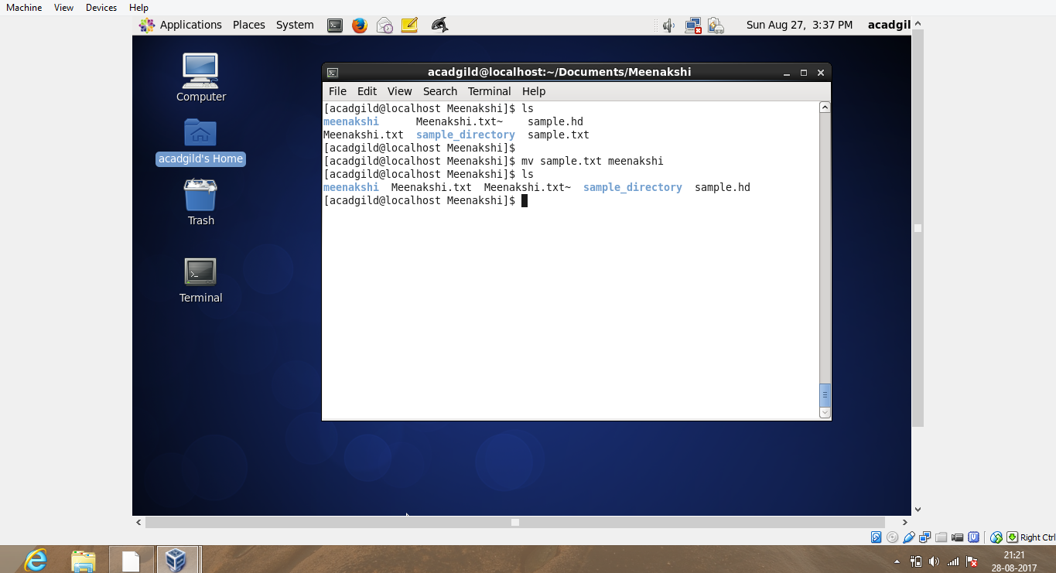

1. **cp :**  This command is used to copy files and directories. It creates a copy of the file in the [working directory](https://www.computerhope.com/jargon/c/currentd.htm) . The copy will be located in the working directory.

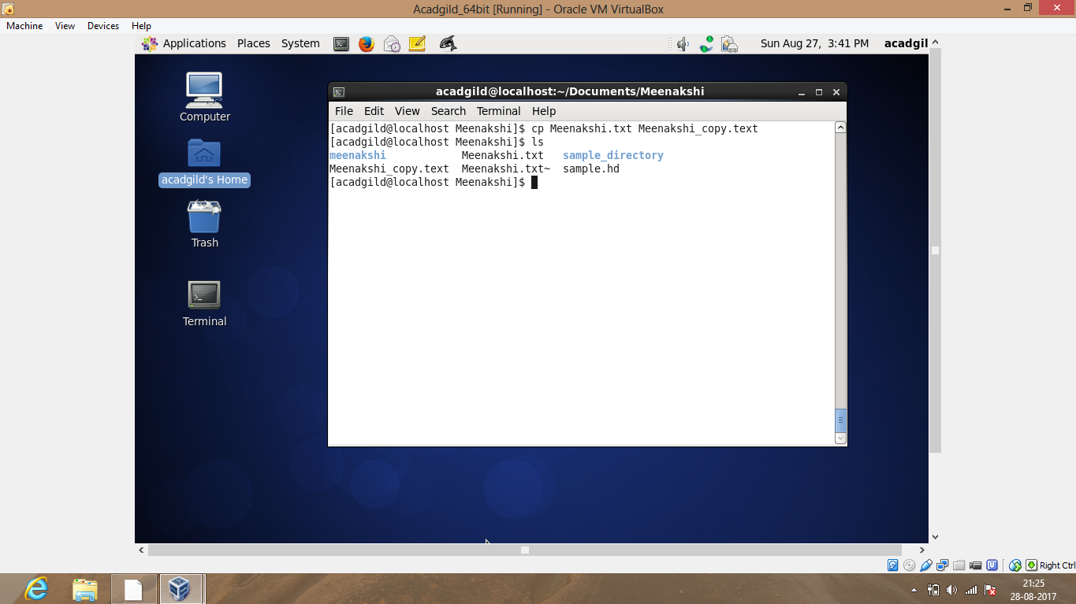

1. **which :** It returns the [pathnames](https://www.computerhope.com/jargon/p/path.htm) of the [files](https://www.computerhope.com/jargon/f/file.htm) which would be [executed](https://www.computerhope.com/jargon/e/execute.htm) in the current [environment](https://www.computerhope.com/jargon/e/environm.htm).

